

Jmeter Performance Testing

Winter 2016 – Author: Thao Le

Contents

1. Week 3: Toolbars, Log Into A Website, Regular Expression Extractor 4

2. Contact Us 8

# Week 3: Toolbars, Log Into A Website, Regular Expression Extractor

* Jmeter Toolbars: File, Edit, Search, Run, Options, Help
  + File: Close, Open, Template, Merge (to merge 2 test plans become 1 test plan), Save, Save Test Plan As, Revert (to get back to the previous test plan), List of recently Test Plans.
  + Edit: Clear, Cut, Copy, Paste, Duplicate, Reset Gui, Remove, Undo, Redo, Open…, Merge, Save Selection As, Save Note As Image, Save Screen As Image, Enable, Disable, Toggle(to enable or disable), Help.
  + Search: Search, Reset Search.
  + Run: Start, Start no pauses, Remote Start, Remote Start All, Stop, Shutdown, Remote Stop, Remote Stop All, Remote Shutdown, Remote Shutdown All, Remote Exit, Remote Exit All, Clear, Clear All.
  + Options: Function Helper Dialog, Look and Feel, Log Viewer, SSL Manager, Choose Language, Collapse All, Expand All.
  + Help: Help, What’s this node, Enable debug, Disable debug,
* HTTP Cookie Manager:
  + It stores and sends cookies just like a web browser. If you have an HTTP Request and the response contains a cookie, the Cookie Manager automatically stores that cookie and will use it for all future requests to that particular web site. Each JMeter thread has its own "cookie storage area". So, if you are testing a web site that uses a cookie for storing session information, each JMeter thread will have its own session. Note that such cookies do not appear on the Cookie Manager display, but they can be seen using the View Results Tree Listener.
  + Clear Cookies each Iteration: If selected, all server-defined cookies are cleared each time the main Thread Group loop is executed. Any cookie defined in the GUI are not cleared.Yes
  + Cookie Policy: The cookie policy that will be used to manage the cookies. "standard" is the default since 3.0, and should work in most cases.
  + Implementation: default is HC4CookieHandler.
* HTTP Request Default
  + This element lets you set default values that your HTTP Request controllers use. For example, if you are creating a Test Plan with 25 HTTP Request controllers and all of the requests are being sent to the same server, you could add a single HTTP Request Defaults element with the "Server Name or IP" field filled in. Then, when you add the 25 HTTP Request controllers, leave the "Server Name or IP" field empty. The controllers will inherit this field value from the HTTP Request Defaults element.
* HTTP Request:
  + This sampler lets you send an HTTP/HTTPS request to a web server. It also lets you control whether or not JMeter parses HTML files for images and other embedded resources and sends HTTP requests to retrieve them. The following types of embedded resource are retrieved:
    - images
    - applets
    - stylesheets
    - external scripts
    - frames, iframes
    - background images (body, table, TD, TR)
    - background sound
  + Instead of manually adding HTTP Requests, you may want to use JMeter's HTTP(S) Test Script Recorder to create them. This can save you time if you have a lot of HTTP requests or requests with many parameters.
  + If the request uses cookies, then you will also need an HTTP Cookie Manager. You can add either of these elements to the Thread Group or the HTTP Request. If you have more than one HTTP Request that needs cookies, then add the elements to the Thread Group. That way, all HTTP Request will share the same Cookie Manager elements.
* Create A Test Plan To Log Into A Website
  + In this section, you will learn how to create a Test Plan to login a Web site. You will send requests to login www.clinique.ca Web site. To construct the Test Plan, you will use the following elements: Thread Group, HTTP Request, HTTP Request Defaults, HTTP Cookie Manager, Summary Report and View Result Tree.
  + In a web-browser, the login will be shown as a form for the user name and password, and a button to submit the form. To do this in JMeter, add an HTTP Request, and set the method to POST. You'll need to know the names of the fields used by the form, and the target page. You can use the JMeter Proxy Recorder to record the login sequence. Enter the username and password details. Sometimes the login form contains additional hidden fields. These will need to be added as well.

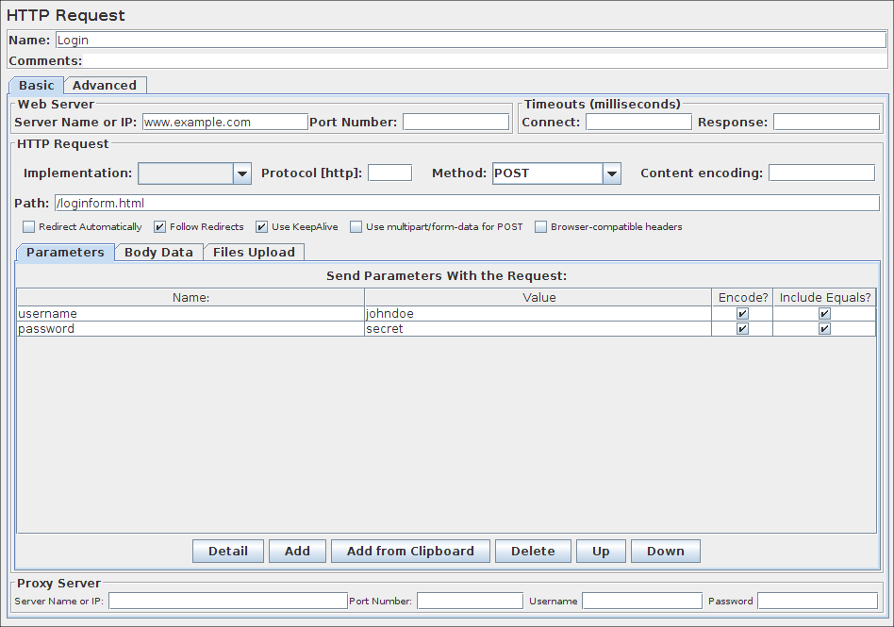

* **Regular Expression Extractor**
  + A regular expression is a pattern that the regular expression engine attempts to match in input text. A pattern consists of one or more character literals, operators, or constructs.
  + Regular Expression Extractor in Jmeter is used to extract a value from the response based on a Regular Expression Pattern.
  + A pattern can be used for “matches” or “contain”:
    - "contains" : means that the regular expression matched at least some part of the target, so 'alphabet' "contains" 'ph.b.' because the regular expression matches the substring 'phabe'.
    - "matches" : means that the regular expression matched the whole target. So 'alphabet' is "matched" by 'al.*t'.
  + Example: Extract single string
    - Suppose you want to match the following portion of a web-page:

name="fileName" value="readme.txt">

And you want to extract readme.txt.

A suitable regular expression would be:

Regular Expression: name="file" value="(.+?)">

Reference Name: SampleRegularExpression

Template: $1$

Match No. : 1

* + - The special characters above are:

( and ) these enclose the portion of the match string to be returned

. match any character

+ one or more times

? stop when first match succeeds

$1$ only 1 group value

Match No.=1 mean get only 1 value

* + Example: Extract multiple strings
    - Suppose you want to match the following portion of a web-page:

name=" fileName1 " value="readme1.txt">

name=" fileName2 " value="readme2.txt">

And you want to extract “filename” and “readme.txt”

A suitable regular expression would be:

Regular Expression: name="(.+?)" value="(.+?)">

Reference Name: SampleRegularExpression

Template: $1$$2$”

Match No. : 0

* + - The special characters above are:

( and ) these enclose the portion of the match string to be returned

. match any character

+ one or more times

? stop when first match succeeds

$1$$2$ 2 groups value will be return: SampleRegularExpression_g1=filename and SampleRegularExpression_g2=readme.txt

Match No.=0 mean get all the values that match Regular Expression

To get the Count values from Regular Expression, using matchNr. In this case, SampleRegularExpression_matchNr=2

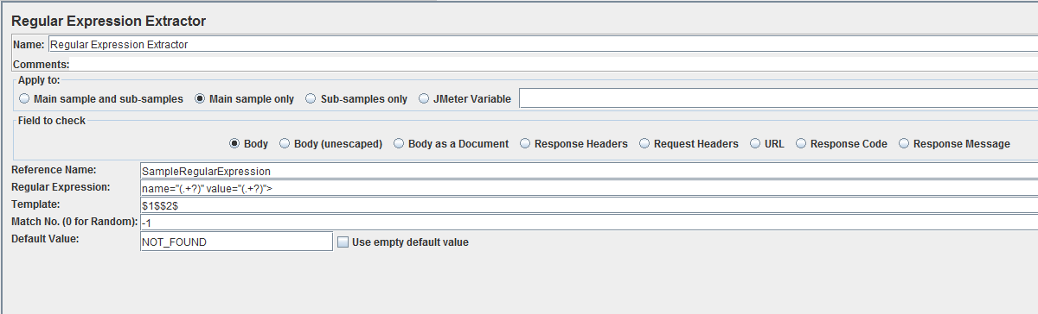

* + Using “Debug PostProcessor” listener to debug the values returning by Regular Expression Extractor

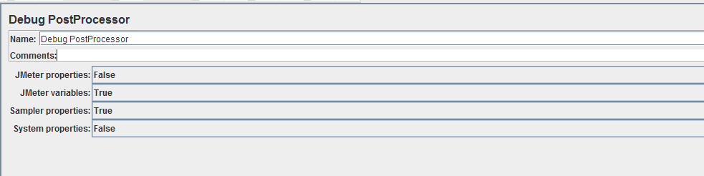

* + Using RegExp Tester to test for Regular Expression from the Response

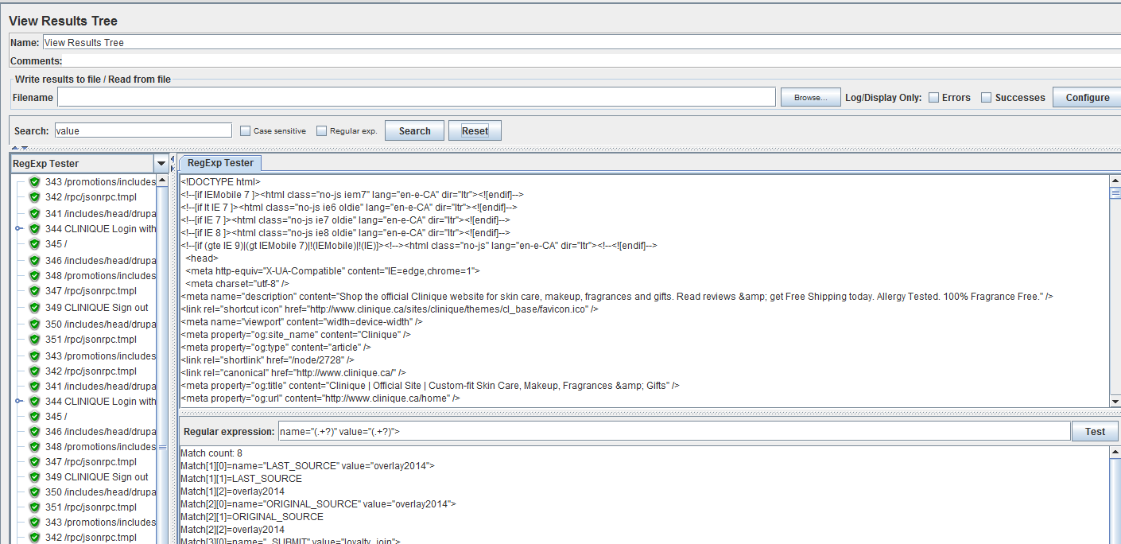

* + More information about Regular Expression: https://msdn.microsoft.com/en-us/library/az24scfc(v=vs.110).aspx